Magnis - Management Operating System (MOS)
Technical Specification

Contents
1. Introduction 3
1.1 Purpose 3
1.2 Key Future 4
1.3 Scope 4
1.4 Definitions and Acronyms 4
1.5 References 5
2. System Overview 5
2.1 System Description 5
3. Technology Stack 6
4. Functional Modules 8
5. Database Design 11
6. API Specifications 14
6.1. API Architecture Overview 14
6.2. Workflow Entities (Data Models) 14
6.2.1 Create Workflow API 14
6.2.2 Save Draft 15
6.2.3 Get Workflow Details 15
6.2.4 Update Workflow 15
6.2.5 List Workflows 16
6.2.6 Delete Workflow 16
6.3 Workflow Steps APIs (Next Step Screen) 16
6.3.1 Add Step 16
6.3.2 Get Steps 17
6.3.3 Update Step 17
6.3.4 Delete Step 17
6.4 Validation Rules 17
6.5 Error Handling 17
7. Security Requirements 18
8. Performance Requirements 19
9. Deployment Architecture 20
10. Logging and Monitoring 21
11. Testing Strategy 22
12. Assumptions and Constraints 23
13. Future Enhancements 24

1. Introduction
The Management Operating System (MOS) is a digital platform that replaces manual processes with automated workflows to plan, execute, track, and optimize operations across the organization.
User group & Role configuration has been referred to in Remote Diagnostic Tool master should be referred in existing details.

Purpose
The purpose of this document is to define the technical specifications for the development and implementation of the Management Operating System (MOS) is a digital platform that replaces manual processes with automated workflows to plan, execute, track, and optimize operations across the organization.
This document provides a detailed description of:
- System architecture
- Functional modules
- Database structure
- API interfaces
- Security requirements
- Deployment environment
The document serves as a reference for developers, system architects, testers, and project managers involved in the project.

Key Future
- Workflow builder (build, import, or use templates)
- Question, answer and work sheet builder
- Automated activity sequencing and scheduling
- My work inbox and forms for activity execution
- Automated reminders via Teams/Outlook
- Outlook calendar integration for scheduling meetings and To Do’s
- Role-based access and activity handovers (future)
- Standardized meeting setup using 5Ps
- Real-time progress dashboards
- RACI workflow step assignment and activity execution tracking
- Separate mobile formatted pages for in-the-field usage

Scope
The Management Operating System (MOS) will allow users to:
- Create and manage tasks
- Assign tasks to team members
- Monitor project progress
- Track deadlines and priorities
- Generate reports
The system will be accessible through web browsers and will support multiple users with role-based access control.

Definitions and Acronyms
Term | Definition
API | Application Programming Interface
UI | User Interface
DB | Database
JWT | JSON Web Token
REST | Representational State Transfer
CRUD | Create, Read, Update, Delete

References
- IEEE Software Requirement Specification Guidelines
- REST API Design Standards
- OWASP Security Best Practices

2. System Overview

2.1 System Description
The Management Operating System (MOS) is a web-based single page application designed to help organizations manage projects and tasks efficiently.
The system will allow:
- Managers to assign tasks
- Employees to update task progress
- Administrators to manage users
The system will support real-time updates, notifications, and reporting features.

2.2 System Architecture
The system will follow a three-tier architecture.
1. Presentation Layer
User interface built using modern web technologies.
2. Application Layer
Business logic and API services.
3. Data Layer
Database storage and management.

2.3 Architecture Components
Component | Description
Frontend | Web interface for users
Backend | Application logic
Database | Data storage
API | Communication between frontend and backend

3. Technology Stack
Layer | Technology
Frontend | Angular
Backend | Web API
Database | PostgreSQL
Authentication | JWT
Hosting | Azure Cloud
Version Control | Git

4. Functional Modules
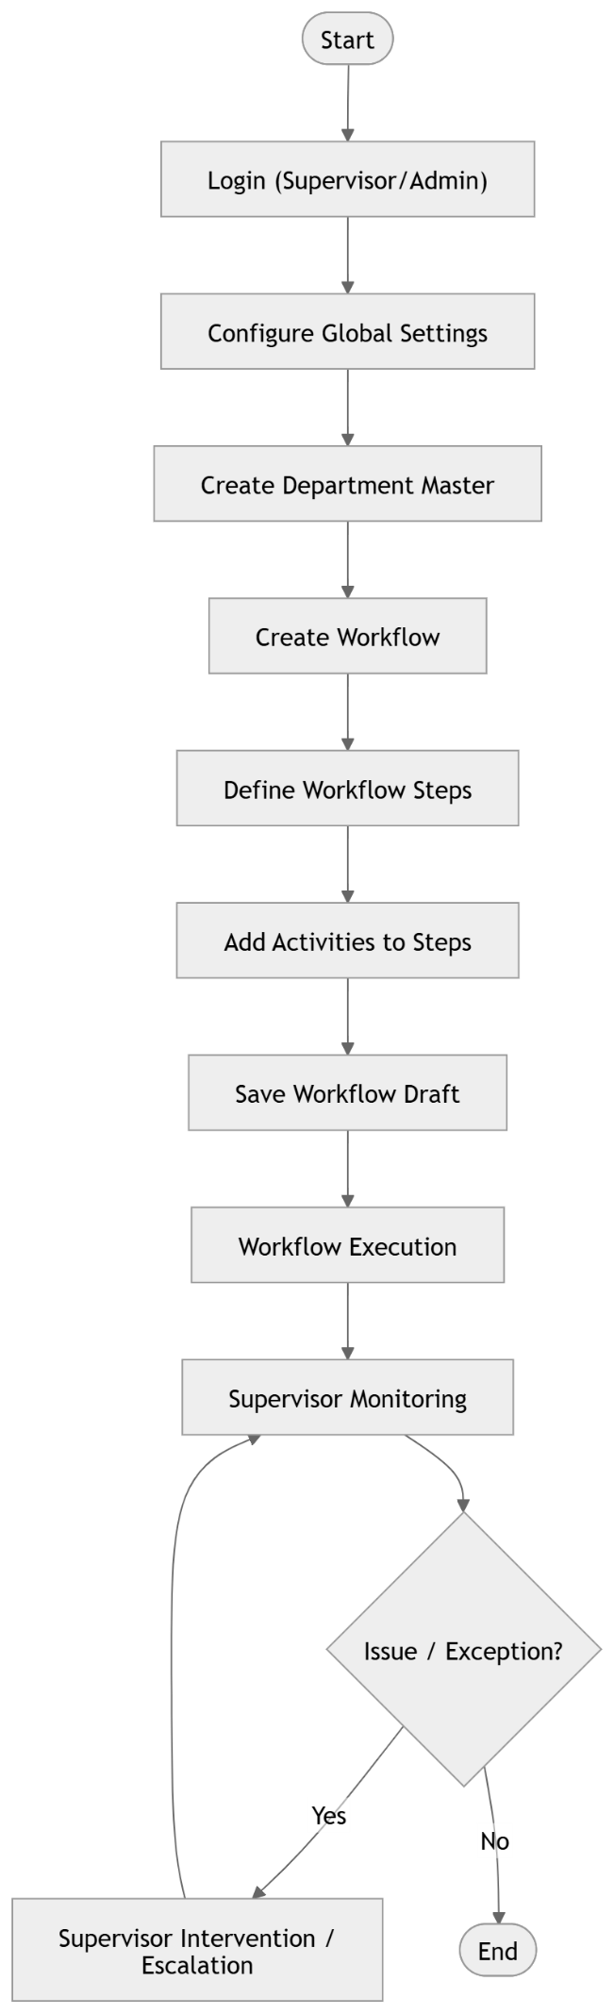
4.1 User Management Module
Features include:
- User registration
- Login authentication
- Password reset
- Role-based permissions
Roles
Role | Description
Admin | Full system control
Manager | Assign tasks
Employee | Work on assigned tasks

4.2 Task Management Module
This module allows users to manage tasks.
Functions
- Create task
- Assign task
- Update task status
- Set deadlines
- Add comments
Task Status Types
Status | Description
Pending | Task created but not started
In Progress | Task currently being worked on
Completed | Task finished

4.3 Notification Module
This module provides notifications for important events.
Examples:
- Task assignment alerts
- Deadline reminders
- Task completion updates
Notifications may be delivered via:
- Email
- In-app alerts

4.4 Reporting Module
The reporting module provides analytics and summaries.
Reports include:
- Task completion reports
- Project progress reports
- Employee productivity reports
Reports can be exported as:
- PDF
- Excel

5. Database Design
5.1 Database Overview
The system will use PostgreSQL relational database.
Key entities include:
- Activities
  - Global Settings
  - Department
  - Workflow
  - Steps
  - Activity
- Supervisor Persona
Database Diagram:
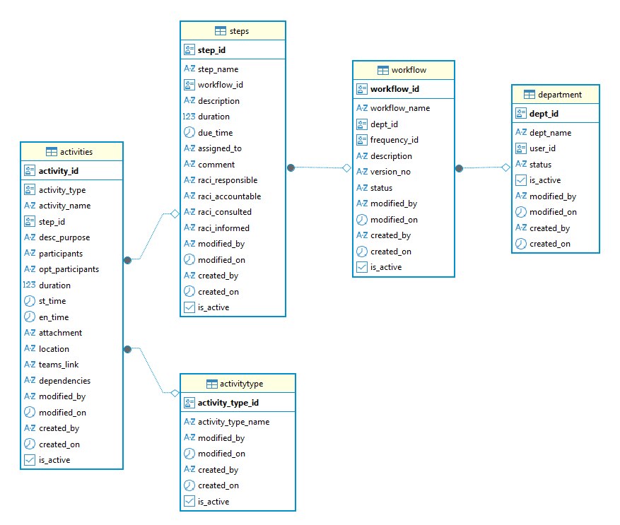

5.2 Database Tables
Department Table
Field | Type | Description
dept_id | GUID | Primary Key
dept_name | VARCHAR | Department Name
user_id | INT | Owner
status | VARCHAR | Status
Is_active | BOOLEAN | Is Active
modified_by | VARCHAR | User
modified_on | TIMESTAMP | Department Last Updated
created_by | VARCHAR | User
created_on | TIMESTAMP | Department Creation

Workflow Table
Field | Type | Description
workflow_id | GUID | Primary Key
workflow_name | VARCHAR | Workflow Name
dept_id | GUID | Department – LOV
frequency_id | INT | Frequency – LOV
Description | TEXT | Description
modified_by | VARCHAR | User Reference
modified_on | TIMESTAMP | User Last updated
created_by | VARCHAR | Created User
created_on | TIMESTAMP | Workflow Creation
version_no | INT | Version Number
status | INT | Action

Steps Table
Field | Type | Description
step_id | GUID | Primary Key
step_name | VARCHAR | Step Name
workflow_id | GUID | Workflow Reference
Description | TEXT | Description
Duration | INT | Duration
due_time | INT | Due Time – LOV
assigned_to | VARCHAR | Assigned To – User Master
status | INT | Status
comment | TEXT | Comment
raci_responsible | TEXT | R
raci_accountable | TEXT | A
raci_consulted | TEXT | C
raci_informed | TEXT | I
created_by | INT | Created User
created_on | TIMESTAMP | Step Creation
updated_by | INT | Updated User
updated_on | TIMESTAMP | Step Modification

Activity Table
Field | Type | Description
activity_id | GUID | Primary Key
activity | TYPE | Activity Type (Activity/Meeting/Form)
name | TEXT | Name (Activity/Meeting/Form)
desc_purpose | TEXT | Description/Purpose
participants | TEXT | Participants
opt_participants | TEXT | Optional Participants
duration | INT | Duration
st_time | TIME | Start Time – LOV
en_time | TIME | Due/End Time – LOV
attachment | TEXT | Attachment
location | INT | Location - LOV
teams_link | TEXT | Teams Link
dependencies | TEXT | Dependencies – LOV
created_by | INT | Created User
created_on | TIMESTAMP | Step Creation
updated_by | INT | Updated User
updated_on | TIMESTAMP | Step Modification

6. API Specifications

6.1. API Architecture Overview
- Architecture Style: RESTful APIs
- Protocol: HTTPS
- Data Format: JSON
- Authentication: JWT / OAuth2
- Versioning: /api/v1/
- Base URL:

6.2. Workflow Entities (Data Models)
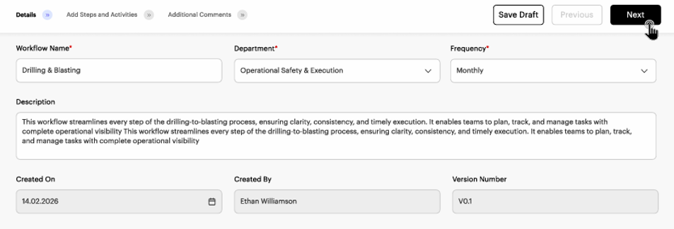
Field | Type | Required | Description
workflowId | UUID | Yes | Unique workflow identifier
workflowName | String | Yes | Name of workflow
Department | String | Yes | Department responsible
Frequency | String | Yes | Monthly / Weekly / Daily
description | String | No | Workflow description
createdOn | Date | Yes | Workflow creation date
createdBy | String | Yes | User who created workflow
versionNumber | String | Yes | Workflow version
Status | String | Yes | Draft / Active / Archived
updatedOn | Date | No | Last update date

6.2.1 Create Workflow API
Endpoint: POST /api/v1/workflows
Request: Body Json
{
"workflowName": "Drilling & Blasting",
"department": "Operational Safety & Execution",
"frequency": "Monthly",
"description": "This workflow streamlines every step of the drilling-to-blasting process.",
"versionNumber": "V0.1",
"createdBy": "Ethan Williamson"
}
Response: Raw Text
{
"workflowId": "wf-98765",
"message": "Workflow created successfully",
"status": "Draft"
}

6.2.2 Save Draft
Triggered by Save Draft button
Endpoint: POST /api/v1/workflows/draft
Request: Body Json
{
"workflowName": "Drilling & Blasting",
"department": "Operational Safety & Execution",
"frequency": "Monthly",
"description": "Draft workflow",
"versionNumber": "V0.1"
}

6.2.3 Get Workflow Details
Endpoint: GET /api/v1/workflows/{workflowId}
Response: Raw Text
{
"workflowId": "wf-98765",
"workflowName": "Drilling & Blasting",
"department": "Operational Safety & Execution",
"frequency": "Monthly",
"description": "This workflow streamlines every step...",
"createdOn": "2026-02-14",
"createdBy": "Ethan Williamson",
"versionNumber": "V0.1"
}

6.2.4 Update Workflow
Endpoint: PUT /api/v1/workflows/{workflowId}
Request: Body Json
{
"workflowName": "Drilling & Blasting Updated",
"frequency": "Weekly",
"description": "Updated workflow description"
}

6.2.5 List Workflows
Endpoint: GET /api/v1/workflows
Query Parameters
Parameter | Value
department | Safety
status | Active
page | 1
pageSize | 10
Response: Raw Text
List of workflow details

6.2.6 Delete Workflow
Endpoint: DELETE /api/v1/workflows/{workflowId}

6.3 Workflow Steps APIs (Next Step Screen)
Workflow Step Entities (Data Models)
Field | Type | Description
stepId | UUID | Step identifier
workflowId | UUID | Parent workflow
stepName | String | Step title
description | String | Step details
sequence | Integer | Step order
assignedRole | String | Responsible role

6.3.1 Add Step
POST /api/v1/workflows/{workflowId}/steps

6.3.2 Get Steps
GET /api/v1/workflows/{workflowId}/steps

6.3.3 Update Step
PUT /api/v1/workflows/{workflowId}/steps/{stepId}

6.3.4 Delete Step
DELETE /api/v1/workflows/{workflowId}/steps/{stepId}

6.4 Validation Rules
Field | Validation
Workflow Name | Required, Max 100 chars
Department | Required
Frequency | Enum (Daily, Weekly, Monthly)
Version Number | Pattern Vx.x
Description | Max 1000 chars

6.5 Error Handling
Code | Meaning
400 | Validation error
401 | Unauthorized
404 | Workflow not found
500 | Internal server error

7. Security Requirements
Security measures include:
Authentication
- JWT-based authentication
- Secure password hashing using bcrypt
Data Protection
- HTTPS communication
- Encryption of sensitive data
Security Practices
- Input validation
- SQL injection prevention
- Cross-site scripting (XSS) protection

8. Performance Requirements
The system should meet the following performance targets:
Requirement | Target
Concurrent Users | 500 users
API Response Time | < 2 seconds
Database Query Time | < 500 ms
Performance optimization techniques include:
- Database indexing
- Query optimization
- Caching frequently accessed data

9. Deployment Architecture
The system will be deployed using cloud infrastructure.
Deployment Components
Component | Technology
Web Server | Nginx
Application Server | Angular & Web API
Database Server | PostgreSQL
Cloud Platform | Azure

CI/CD Pipeline
Deployment will be automated using:
- GitHub Actions
- Docker containers
- Continuous integration and testing

10. Logging and Monitoring
Monitoring tools will track system performance and errors.
Logging
System logs will capture:
- User activities
- API requests
- System errors
Monitoring Tools
Tool | Purpose
Prometheus | Performance monitoring
Grafana | Visualization dashboards
ELK Stack | Log analysis

11. Testing Strategy
Testing will include multiple phases.
Unit Testing
Tests individual components of the system.
Integration Testing
Tests interactions between modules.
System Testing
Validates the entire system functionality.
User Acceptance Testing (UAT)
Conducted by end users before production deployment.

12. Assumptions and Constraints
Assumptions
- Users have stable internet access.
- Users are familiar with web-based systems.
Constraints
- Development timeline: 4 months
- Budget limitations
- Browser compatibility requirements

13. Future Enhancements
Potential improvements include:
- Mobile application support
- AI-based task prioritization
- Integration with third-party tools (Slack, Jira)
- Advanced analytics dashboard
    - Created By
    - Version Number
    - Action [Save Draft]
    - Steps Master table Reference

